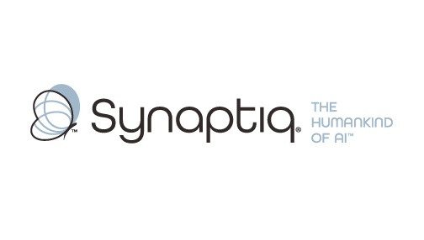
______________________________________________________________________
 | Stephen Sklarew  CEO & Co-Founder, Synaptiq  AI Strategy & Workforce Transformation | "The Humankind of AI"

Overview
Dr. Tim Oates is a distinguished AI and machine learning expert with over 25 years of experience delivering practical computer vision and predictive analytics solutions across manufacturing, healthcare, and industrial environments. As Chief Data Scientist at Synaptiq, he specializes in guiding organizations through strategic AI initiatives, having led computer vision implementations that deliver measurable ROI in quality control, safety monitoring, and operational efficiency. Tim's approach combines rigorous technical expertise with deep understanding of manufacturing realities, helping teams avoid common pitfalls while identifying high-impact use cases that align with business objectives. His 150+ peer-reviewed publications and hands-on consulting experience uniquely position him to share proven frameworks for scoping, prioritizing, and implementing vision-based AI solutions that drive sustainable value.
Background & Expertise
Dr. Tim Oates is a seasoned AI and machine learning leader with over 25 years of experience translating cutting-edge computer vision research into practical manufacturing and industrial applications. As Chief Data Scientist at Synaptiq, Tim specializes in guiding organizations through strategic AI transformations, with particular expertise in computer vision deployments that deliver measurable business value in manufacturing environments. His approach emphasizes learning from industry successes and failures to help teams make informed investment decisions and avoid costly missteps.
Tim's recent consulting portfolio demonstrates deep expertise in manufacturing-relevant computer vision applications. His projects include implementing machine vision systems for construction site safety and productivity optimization at Skanska, developing quality control and defect detection systems, creating predictive maintenance solutions using visual inspection data, and designing computer vision applications for supply chain optimization. This hands-on experience across diverse industrial contexts gives him unique insight into where vision AI delivers real ROI versus where organizations commonly over-invest or under-scope their initiatives.
Prior to his current role, Tim served as Chief Scientist at CircleBack (now SalesIntel), where he led the development of large-scale AI systems for data processing and entity recognition—experience directly relevant to the challenges of deploying computer vision at industrial scale. His academic foundation as a postdoctoral associate in the MIT Artificial Intelligence Lab, combined with his practical implementation experience, provides a rare perspective on bridging the gap between promising AI concepts and production-ready manufacturing solutions.
Tim's thought leadership in AI is evidenced by his 150+ peer-reviewed publications covering computer vision, machine learning, and industrial applications. As an Oros Family Professor of Computer Science at the University of Maryland, Baltimore County, he maintains active research connections while staying grounded in real-world implementation challenges. His dual perspective as both researcher and practitioner enables him to help organizations navigate the hype around computer vision while focusing on applications with proven business impact. Tim holds a Ph.D. and M.S. in Computer Science from the University of Massachusetts, Amherst, where his foundational work in machine learning continues to inform his practical approach to AI strategy and implementation.
Relevant Experience
- Manufacturing Computer Vision Implementation: Led machine vision deployment at Skanska for construction site safety and productivity monitoring, delivering continuous operational improvements. Developed frameworks for ROI measurement and use case prioritization in industrial environments.
- Quality Control and Defect Detection Systems: Designed and implemented computer vision solutions for automated quality inspection and defect detection across manufacturing environments. Specialized in balancing accuracy requirements with production speed constraints.
- Industrial AI Strategy and Roadmapping: Guided multiple manufacturing organizations through AI readiness assessments and strategic planning processes. Developed proven methodologies for identifying high-impact computer vision use cases while avoiding common implementation pitfalls.
- Predictive Maintenance with Visual Analytics: Implemented machine learning systems that combine computer vision with predictive analytics for equipment maintenance optimization. Demonstrated measurable ROI through reduced downtime and maintenance costs.
- Large-Scale AI System Architecture: Architected and deployed AI systems at industrial scale during tenure as Chief Scientist at CircleBack, managing entity extraction and recognition across massive datasets. Expertise in production deployment challenges and scalability considerations.
- Cross-Industry Vision AI Applications: Successfully implemented computer vision solutions across healthcare, construction, cybersecurity, and logistics industries. Deep understanding of how vision AI applications translate across different operational contexts and regulatory environments.

